Finance & Corporate Services Director

Job Pack

August 2022

About AFK

AFK supports disabled children and young people to live independent and fulfilling lives.

There are two main themes to our work: employment and mobility. We help disabled and autistic young people aged 18-25 to develop important life and work skills so they can live more independently and move into paid employment. On the mobility side we provide specialist mobility equipment not available on the NHS to disabled children and young people up to their 25th birthday, across the UK.

This is an exciting time to be joining AFK as we have recently embarked on a three year growth strategy to increase our service provision. There are 14 million disabled people in the UK and we know disabled people suffer unemployment disproportionately. As we begin to come out of the pandemic our work will be more vital than ever to ensure that disabled and autistic young people have the support they need to live a fulfilling life.

Summary of the Role
As part of the Senior Management Team you will be responsible for developing and delivering Finance, IT and HR strategy as well as managing the Finance and Corporate Services Department to support colleagues and volunteers to deliver quality services for our trainees and supporters.

The role will deliver high quality services, developing controls and processes to ensure the secure and efficient running of the organisation’s finances, managing relationships with our IT support and suppliers and delivering organisational strategy to ensure that our fabulous service delivery and fundraising teams have the support they need to deliver our exciting new strategies for growth.

Why work at AFK?
AFK has been committed to supporting disabled and autistic children and young people for 30 years and we need the very best talent to keep our mission alive. We are a team of passionate individuals who are 100% committed to making a difference to disabled young people’s lives and to seeing the charity grow so we can support more young people. We take pride in our inclusive work culture and encourage team members to bring their whole self to work.

Our focus is on a young person’s potential and aspirations, not the apparent barriers they face. This is part of the social model of disability, which says that disability is caused by negative attitudes and exclusion within society, rather than the individual’s impairment.

Here at AFK we work to address and remove the social barriers that disable people, by providing mobility equipment, education support, skills training and helping young people secure work placements. We believe these services are an essential part of helping young people succeed.

We believe it’s our social and economic structures that stop disabled people from living an engaged and fulfilling life, not the impairment or disability. This is what we tell our students and trainees: you don’t need to change; society does.

Our values

We are straightforward. We share our experiences, knowledge and understanding about disability, and welcome honest and frank discussion on how to achieve our mission.

We respect & value every individual. We respect you and all our stakeholders. We value every opinion and put disabled people at the centre of what we do.

We are passionate. We were formed by someone who was passionate about ensuring a better future for disabled young people. This passion is still behind everything we do.

We are approachable & supportive. We are an open and outward looking organisation that makes it easy for disabled people and their families to seek help. We build long-term partnerships with those we help.

We are committed. We challenge situations where disabled people do not receive the help, support and understanding they need.

What we offer:

28 days annual leave (in addition to all statutory public holidays), pro-rata for part time

Flexible working arrangement (currently piloting hybrid working with 2 core days in the office and 3 days working from home)

Employer contributory pension scheme

24/7 Employee assistance programme & counselling service

Commitment to allowing a good work/life balance

Employee retail discounts powered by Reward Gateway Foundation

Flu Vaccine reimbursement

Life assurance scheme for those who work over 16 hours per week

Generous Maternity leave pay

Office Closure during Christmas period

Casual dress

Mobility Equipment Project

ELIZA

Eliza is a 6-year old girl from Cornwall. She likes going to school and mixing with
her classmates. She adores her family and has a very close bond with her brother
Charlie, as they both have wheelchairs. She also likes to go swimming and goes to
a heated pool once a week for classes.

Eliza suffered a Global Hypoxic Brain injury at the age of 17 months. She was taken
to Bristol Children’s Hospital and placed in an induced coma on life support. Her
family were advised to say goodbye to her, but when she was taken off life support,
she fought to get better. While in the hospital she lost her sight, hearing and was
having seizures. Over time she regained these, but as she’s grown she has had
increased difficultly with her mobility. She uses hinged splints to help with walking
short distances and uses a wheelchair to get around outside of her home. Her
family say that Eliza ‘simply starts each day the same, happy and full of joy and
love. She is an inspiration.’
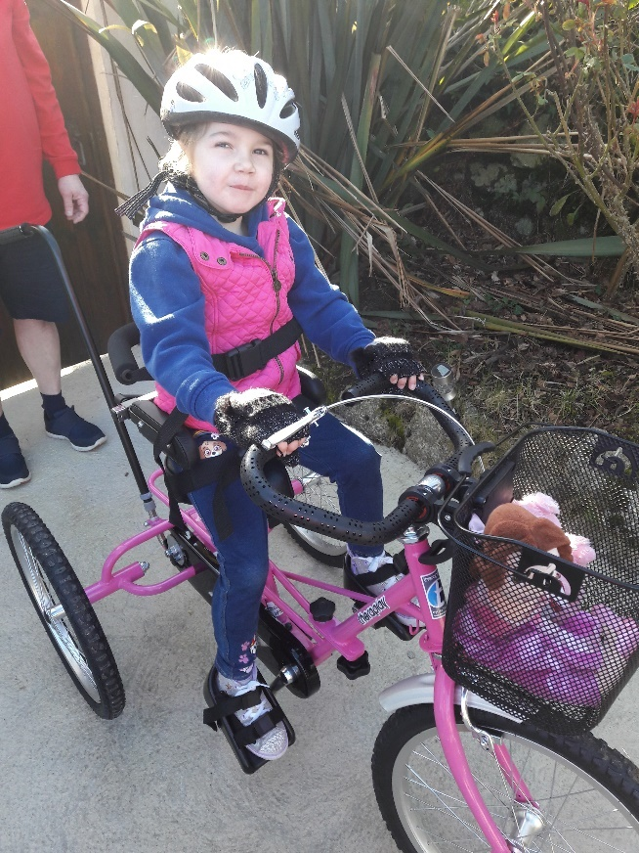
Her family applied to my AFK for funding for
a specialist trike after Eliza’s
physiotherapist suggested the significant
physical, neurological, and psychological
benefits of having an adapted trike. When
she had her assessment, Eliza beamed and
loved the feeling of pedalling. Having a new
trike allowed her to join in on bike rides with
her friends and family, giving her a sense of
freedom and inclusion while building her
confidence and muscles.

When her trike was delivered her father got
in touch to say, “We just wanted to say
thank you and all the team at AFK for
helping Eliza achieve a dream. Her new trike
is absolutely fantastic and we have enjoyed
several bike rides as a family. Eliza has been
so happy on her new wheels. Several ‘cuddlies’ have been selected for the rides so far!!

A GREAT BIG THANK YOU from all of us to you and AFK.”

Life & Work Project

RUBEN

‘To find a job you like is not easy for anyone. It may take longer than a week or a month but if you keep trying and don’t give up and with help from places like AFK, even in this pandemic, you will have a chance’

Ruben is on the autistic spectrum and has a mild learning disability. He came to AFK after his Aunty referred him to the Life & Work team. Having worked as a cleaner for a few years Ruben was ready for his next step. After help from the team in improving his resume and setting out his goals, he was ready to start honing his interview technique, approaching employers and bolstering his skillset.

The team organised to record Ruben’s sessions, answering questions and then listening back to how he articulated himself. This enabled him to hear himself back and make improvements such as slowing down with his speech and taking his time in explaining different aspects of his experience and how these would help him in the role. Whilst he had successfully progressed to the second interview on a couple of occasions, he had not yet been in successful in securing a new position.

A noticeable change in Ruben’s approach to the process was when he completed three separate interviews with three different corporate partners that support AFK. Taking onboard the advice and support given to him, Ruben was displaying a new air of confidence, coming back stronger and stronger for each session. During this time he passed his driving test and moved to his own flat independently. He was gaining traction in his search for a new role, however, Covid-19 put the breaks on this progress.

The first lockdown in March 2020 triggered an 8-month stint of furlough from the Southbank Centre for Ruben. Although grateful to receive government support - meaning he was just about able to maintain his independence – fears over imminent job losses meant he was in danger of losing his new home.

Unfortunately, like many in Ruben’s position, these fears were realised, as he was let go in the autumn due to wave of redundancies.

Not to be disheartened, Ruben had applied for a number of retail roles, yet he found the application process challenging due to the number of online tests before even being considered for an interview.

Continues over page

‘Ruben has displayed great staying power, despite feeling disappointed at not getting through, each time he would pick himself up and start working with AFK once more to apply for the next job role.’ explains Ruben’s Job Coach.
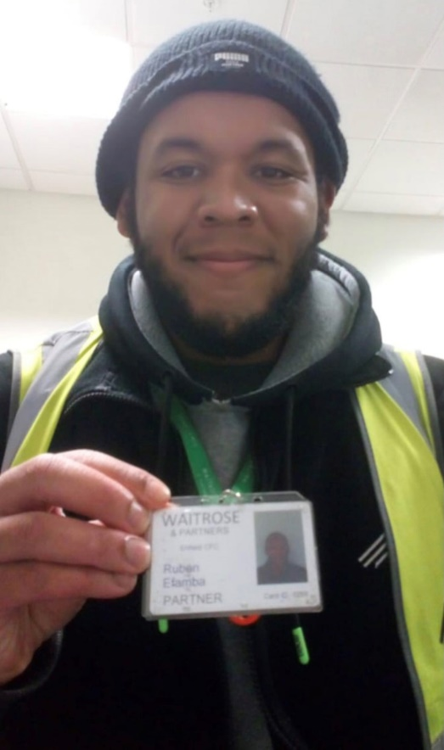
With rent payments looming and no foreseeable pay cheque, AFK helped Ruben with an application to ‘Aid for Asperger’s’, a small charity that helps and support young adults who have Asperger’s Syndrome to improve the condition of their lives. They very generously donated £500 – a large donation for a charity of their size - to cover rent and food as he awaited news of work, for which Ruben is so grateful.

Before long, Ruben had made a successful application to a major supermarket.

‘It all happened in quite a hurry’ he said. Reasonable adjustments were negotiated, meaning Ruben went straight through to an interview and he could concentrate on application details.

‘Ruben mastered the art of making a good impression at an interview.’

This was clearly the case, as within a week of being told of his redundancy, he had been offered a new position working in a supermarket warehouse. Now 24, Ruben’s hopes of changing his career path have come to fruition.

‘My confidence has grown significantly, and it has given me more knowledge in regards to what the job market is all about’ he exclaims.

AFK
JOB DESCRIPTION

Job Title: Finance & Corporate Services Director

Reporting To: CEO

Salary range: £55-60k, depending on experience

Hours: 35 hours per week

Location: Hornsey, London N8 9DJ but subject to review

DBS: This post is subject to a basic criminal record check under the arrangements established by the Disclosure and Barring Service.

Context of Job

AFK is a national charity helping disabled young people to develop their independence and find employment. Our vision is of a world where all people living with a disability get to lead the life they choose. As part of this we provide bespoke employment skills training and organise work experience. At a national level, we provide mobility equipment not available on the NHS for disabled children and young people up to their 25th birthday.

Working within the Senior Management team, and with the wider F&CS team, this position will play a valuable role in developing and delivering organisational strategy and supporting colleagues, volunteers and other stakeholders across the organisation.

Main Purpose of Job

As part of the Senior Management Team you will be responsible for developing and delivering Finance, IT and HR strategy as well as managing the Finance and Corporate Services Department to support colleagues and volunteers to deliver quality services for our trainees and supporters.

The role will deliver high quality services, developing controls and processes to ensure the secure and efficient running of the organisation’s finances, managing relationships with our IT support and suppliers and delivering organisational strategy to ensure that our fabulous service delivery and fundraising teams have the support they need to deliver our exciting new strategies for growth.

The Finance & Resources Department comprises finance, HR, IT and facilities; as a small organisation we have a fairly lean back-office function, so we are looking for a skilled and high-performing candidate who is able and willing to get stuck into the hands-on detail as well as oversee the more high-level and strategic aspects of the role.

You will manage agencies and external suppliers and be a confident communicator.

Working Conditions

The post is 35 hours a week, normally between 9am and 5pm. (We are currently piloting Hybrid working with 2 core days in the office and 3 days working from home with core hours between 10am and 4pm).

The post holder may be expected to work some evenings and weekends as required by the job.

AFK operates a No Smoking policy.

Working Relationships

CEO – Line manager
Fundraising & Comms Director
Executive Director of Services
Finance and Corporate Services team
Fundraising and Communications Team
Service Delivery Team
Volunteers and Suppliers

Principle Responsibilities
Strategic
- To support the development, effective implementation and monitoring of organisational strategy and business plans
- To develop and lead the organisation’s business planning and budget processes
- To work closely with the Treasurer to enable effective scrutiny of the charity by Trustees; and to contribute to, and participate in, all Board meetings and sub-committees
- To act as an enabler, critical friend and constructive challenge within the SMT and to managers and budget holders, leading effective business partnering to drive optimal decision-making.

Finance
- To ensure excellent financial management is in place with effective procedures, processes, and controls to effectively manage risk, embed best practice and to meet regulatory requirements, and to be accountable for all AFK financial processes
- To provide high quality and timely management information to budget holders, SMT and Trustees so that financial and strategic planning is based on sound information and forecasts
- To provide technical support and advice to budget holders to develop strong financial management practices across the organisation, to ensure AFK has the required resources to deliver against its operational objectives
- To work closely with the Director of Fundraising and Comms and with other managers to develop tenders and funding bids, ensuring that appropriate budgets are constructed, financial implications are understood, and VAT rules are applied correctly.
Operations
- To oversee the development of a strong and strategic digital culture that enables AFK to make the most of existing digital technology and new opportunities to improve supporter engagement and service delivery
- To oversee the delivery and maintenance of high-quality information technology infrastructure for the organisation, ensuring that AFK makes the best use of IT to support agile and flexible working and maximise operational efficiency
- To oversee the delivery of high quality facilities support for AFK’s offices and also for agile working and staff working remotely, ensuring AFK provides a positive working environment and is compliant with health and safety legislation
- To oversee the provision of effective HR management across the organisation, ensuring the delivery of high-quality support and advice to AFK staff and supporting organisational performance in line with our values; to continually develop our practice around line management, diversity and inclusion, and learning and development; as well as ensuring AFK is compliant with employment legislation
- To review the legal and contractual arrangements made across all AFK directorates, utilising expertise from our lawyers when appropriate
- To champion value for money across the whole charity and make sure contractual arrangements and leases are appropriate.

- To manage the organisation’s pension scheme and life assurance scheme
- To work with our HR partners to manage payroll, organisational policies and any adhoc HR items
- To maintain and develop organisational appraisal process
- To provide a full HR service from onboarding to exit interview
- Managing all aspects of our offices including maintenance and provision of services and insurance
- Acting as the organisation’s Data Protection Officer
- Taking overall responsibility for health and safety
IT
- Work with our IT partner to ensure timely resolution of issues
- Develop and deliver IT strategy
- Work with our VoIP, mobile phone and other partners to deliver a complete service to colleagues and volunteers
Organisational
- To provide great leadership and line management for the Finance and Operations Directorate, driving quality and performance and providing support and development for team members
- To establish and maintain effective working relationships both inside and outside the charity, particularly with our auditors, bank, the Charity Commission, and Companies House, so that AFK is always perceived as a professional, efficient and ethical organisation
- To undertake the role of Company Secretary, ensuring AFK is compliant with statutory and regulatory requirements.
Business Planning and Management
- Leading business planning for new initiatives
- In association with the Services Director, managing our planned Social Enterprise Centre
Other
- Deputise for the CEO in their absence
- Provide support for the Board in terms of minutes, Charity Commission and Companies House documentation
- Attending board meetings and reporting to the board of trustees
- Any other duties as may be reasonably requested by the Chief Executive.

Candidates will be evaluated on the following:
- Qualified accountant (ACA, CIMA, ACCA)

- Minimum 3 years experience of finance and administration at a senior level, including financial management and budgetary control in an organisation with £2m turnover or above

- Experience of working in the fields of HR and IT

- Strategic planning at a senior level

- Ability to build and maintain relationships with colleagues, volunteers and suppliers

- Strong communication skills as the role involves regular communication with our supplier partners both face to face and in writing

- Ability to manage multiple priorities and strong organisational skills

- Demonstration of excellent attention to detail

- Ability to demonstrate a commitment to the aims and objectives of AFK

- Willingness to work outside of normal hours if required

- Willingness to undertake other duties which are in line with the general level of responsibility of the post

Code of Conduct and Compliance

- Delivery of all aspects of this job description are in accordance with AFK’s Equal Opportunities & Diversity Policy

- Understanding of and commitment to Equality, Diversity and Inclusion
- Ensure compliance with relevant Fundraising and Data Protection Regulation including the Fundraising Regulator’s Fundraising Code, the General Data Protection Regulation 2016 (GDPR) and the Data Protection Act 2018

For an informal chat about the role, contact David Coe, CEO, on 07907 080063 or at david.coe@afkcharity.org

Please apply here submitting your CV and a cover letter to explain why you are suitable for the role.

