Volunteer Application Form

First Name: Surname:

Address:

Post Code:

Telephone Number: Email:

Emergency Contact Details: Please give details of someone we can contact in an emergency while you are volunteering with us:

What is your current employment status?

1 Employed full time 2 Employed part time 3 Unemployed
4 Student 5 Home maker 6 Other (please state)

Please tell us about your skills and experience (paid or unpaid) that you can use while volunteering with my AFK:

Please tell us:

- Why you are interested in becoming a volunteer?

2) What days/hours are you available each week?

3) How long would you expect to volunteer with us?

How did you find out about our volunteering programme?

Do you have any access requirements? Yes/No
If YES, what additional support will you need?

Do you consider yourself to be in good health? Yes/No
If NO, please describe problem:

*Volunteering with my AFK will require enhanced police check (DBS). Do you have any criminal convictions, spent or unspent? YES/NO. If yes, please briefly explain below what they are.

Please note: With an enhanced check, ALL convictions are shown

Please indicate the areas you are interested in by putting a cross in the box:

Coaching trainees on the Supported Work Placement Programme (weekdays)

Supporting trainees at the charity’s office (weekdays)

Volunteer Tutor/Instructor (virtual sessions or Edible Garden)

Supporting the Fundraising team with fun charity events throughout the year (weekends and evenings)
www.my-afk.org

References

We reserve the right to request references if necessary.

*Not required if taking part in fundraising & attending charity events.

Please sign and return this form to the address at the front of the application. We will contact you shortly and invite you to an informal meeting which will give you a chance to find out more about our volunteering induction programme.

Signature: Date:

my AFK, 15A Tottenham Lane, London N8 9DJ



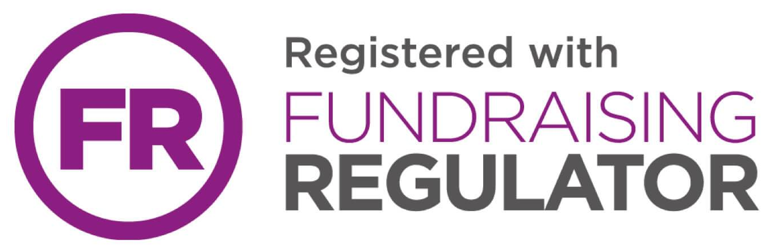
Website: www.my-afk.org Telephone: 020 8347 8111
Email: fsouthworth@my-afk.org Fax: 020 8347 3482

my AFK is the operating name of Action For Kids Charitable Trust, a charity registered
in England and Wales, no. 1068841 and a company limited by guarantee with
charitable status, no. 3487626 governed by memorandum and articles of association.

